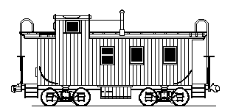

CLIFTON TOWN COUNCIL SPECIAL MEETING
WEDNESDAY, OCTOBER 28, 2026, 6:30 PM
WAYNE H. NICKUM COMMUNITY MEETING HALL
12641 CHAPEL ROAD
CLIFTON, VIRGINIA 20124

- Apply Policy for Remote Participation by Electronic Means for Town of Clifton (if needed).

- Announcement of the Town Council Candidates
- Outstanding Payment Approvals

- Adjournment.

